CONTROL SYSTEMS



# Placeholder image

## **TIME AND FREQUENCY DOMAIN**

TIME DOMAIN:

Time domain as the name suggests is the function where we put time as the input and get the desired output. For example, the distance travelled during a constant velocity of 3m/s is

3t (SI units). Hence this is information about a body represented in the time domain.

We can extend our analogy to functions like waves. The sound wave for example can be ideally represented as y= Acos(wt+k). I plot it on a graph with time on the x-axis and the y coordinate on the y axis. This is also the information of a system represented as a function of time hence a Time domain.

FREQUENCY DOMAIN:

Frequency domain is also the same, just the time is replaced by frequency and the information is represented in a different way. Most of the time this helps us to simplify the system’s data and this helps us to visualise easily. For example : I am bouncing a ball 5 times every second to a height of 1 metre. So I can say that the frequency of a ball going to a height of 1 metre is 5Hz (SI units).

We can again use this analogy to express complex data like waves. Let's say we are observing a wave given by the equation : y=5sin(2t). This wave reaches its amplitude that is 5 in every $π$ seconds $⇒ frequency is 1/π Hz.$ We can say that it has 5 amplitude in frequency

1/ $Π Hz.$ Not just this height it is going to convert everything from 0-5 in the same frequency hence we plot it by joining points that go like (0, $1/π$),(0.1, $1/π$)....(5, $1/π$). We get a vertical line from (0, $1/π$) to (5, $1/π$).

We will further extend our analogy to complex waves : A combination of waves…

Assume a car is travelling at a constant speed of 5 m/s . I can very well say that it travels 2m/s and 3m/s simultaneously and covers some distance. Take wave W1 : 5cos(2 $π$ t) for instance. Superimpose it on another wave W2 : 6sin $π$ t). We can say that final wave W3 is covering both waves simultaneously. We can write the time domain as the sum of both the waves and y as the height. This gives me a beautiful yet useless graph because inferring something from it is complicated. But If its data is plotted in frequency domain it gets easier. It is going to a height of 5 with a frequency of 1 Hz and add it with 6 which is going with a frequency of 0.5 Hz. We represent it with two vertical lines like before. We can disintegrate periodic functions even if we don't know the component waves just like this.

BUT HOW?

Here is where FOURIER ANALYSIS comes into picture !

### **FOURIER ANALYSIS**

This guy disintegrated periodic functions into waves.That's it! He gave a formula to do so which is not really pretty like the result but it comes in handy. The formula is :

$$f(x)=\sum_{-∞}^{∞}{}Cn e^{inπx/T}$$

$Cn=\frac{1}{2T}\int_{-T}^{T}{}f(x){e^{-inπx/T}}^{}dx{}^{}$

Here n gives you the nth wave. A few things to notice here:

1. The euler's term is here to give the phase angle and frequency to the wave. Let's say all the waves start (where height is zero) at origin then it will be fixed that resulting will be also zero but that might not be the case.
2. The T here denotes half the period of the periodic function. Hence the angular frequency of The original term is $π$/T.
3. The euler term gives an angular frequency as wn to the nth wave. The n-th wave’s angular frequency is exactly n times the original or you might say fundamental frequency. Suppose it wasn't true, assume that we want fundamental to be 3 Hz .If one of its parts are say 10 Hz then the final wave will give me 10 peaks or 10/n peaks for some n $∈Z$ but for no n is 10/n =3 . We can generalise the proof like this.
4. We can always change the limits as per our requirement.
5. The summation is from negative to positive infinity which implies infinite terms . This can also be visualised as lets say i have a straight line (be it very small but greater than infinitesimally small) then adding up a finite number of waves wont give me a straight line . If I take $\lim_{n→∞}frequency$ It approaches a graph that almost looks like a straight line (because there are infinite peaks) which works for me.

PLAYING WITH LIMIT IS OUR NEXT PART OF FOURIER ANALYSIS :

I was able to bring out a straight line of a graph using fourier series. What my whole graph is just a bunch of straight lines or more generally It is just a bunch of curves that don't repeat. It tends to think of taking limits to the time period to infinity and see the graph as a single peak repeating after infinite time. This is correct but we have to modify our formula with $\lim_{T→∞}$ so that we can solve non periodic functions too. Here it is:

$$f(x)= \int_{-∞}^{∞}{}F(k)e^{2πikx}dx{}_{}^{}$$

$$F(x)= \int_{-∞}^{∞}{}f(k)e^{-2πikx}dx{}_{}^{}$$

Some points to observe:

1. The T has been replaced by an infinity symbol.
2. There is no fundamental frequency in the equation (of course) and there is no restriction on k . So k can be any real number and will give us all kinds of frequencies.
3. The x is integrated from negative infinity to positive infinity so it is difficult to analyse the functions that are localised in time.
4. This cant be used for all signals ,take |x| For instance, it's not good for analysing unstable systems.
5. Also, this is rarely used to solve differential equations.

Due to limitations we took laplace into our search.

**LAPLACE TRANSFORM**

We have already studied Laplace in our second semester so I am not giving the basics and I'll jump directly to its uses in further sections. Just one thing to note is that we elevate our fourier transform to laplace by multiplying by $e^{σt}$

Which gives us net result as multiplying by $e^{(σ+iω)t}$ before integrating.

**CONTROL SYSTEM**

*OPEN CONTROL SYSTEM :*

Give input, process it, give output.

Eg : Eat food -> process it in our body ->give out energy.

*CLOSED CONTROL SYSTEM :*

Give input, process it, give output, check desired and observed output, give different input accordingly.

Eg : Eat food-> process it in our body -> give out energy -> check if less or more -> eat more or less food …continues…

We use this in our systems. Ofc the closed loop one is sounding better as It reduces the errors over a long interval of time by changing errors and learning from past mistakes.

**TRANSFER FUNCTIONS :**

Above I ate food and processed it to give out energy. Can I build a relationship between them?

Maybe not because it depends on so many factors but whenever we design systems we try to make them simple and efficient. The simplicity is in solving them which is achieved by LINEARITY !

Linear equations are easiest to solve and analyse. Linear functions or precisely Linear Transform Functions are some sort of that only.

It takes input and gives output that is directly proportional to any factor in input and also it simply adds the output of two inputs. That is what linear is.

Linear is basically $a⋅b + c$.

These functions can be represented by an equation (studied in MTH102)

Axe=y where A is a matrix ; x and y are input and output respectively. We say that this A is a transfer function because it transfers input to output. This A can be a $1×1$ matrix (the most often and our case) and then A=T(notation)= y/x.

We can use multiple transfer functions and add the results etc. We use Laplace to represent the function because of its simplicity and its properties.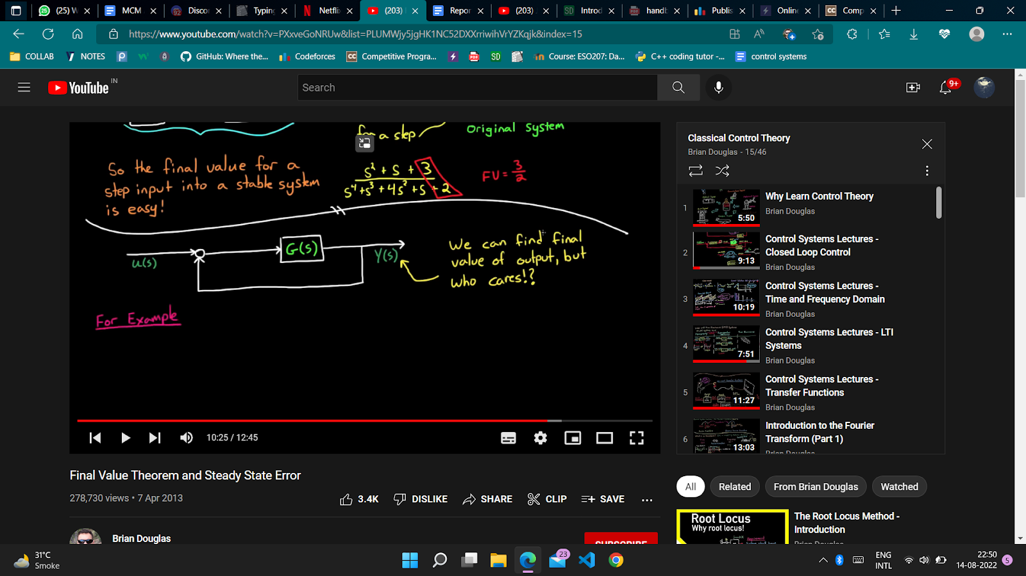

**FOR CLOSED:**

Here the desired input is U(s) and the transfer function is G(s) . The output is Y(s). The error term is E(s). { At start an t<0 Y(s)=0 } The initial Output is given considering the E(s) = U(s).

Hence the first output Y(s) = U(s)G(s). The afterwards Y(s)= E(s)G(s). The error term afterwards will be given by the difference between the Y(s) and the desired one that is U(s). E(s)=U(s)-Y(s). We can solve for E(s) = U(s)/ 1+ G(s). This can be converted into an open loop system with these characteristics.

**Poles and Zeros**

When we write a laplace transform function of a system we define poles and zeros which makes it easy to understand. Poles ($×$) are the points or ‘s’ where the denominator of the transfer function approaches to zero.

Zeroes ($O$) are the same but the numerator goes to zero in this case.

These can be complex or real. Real parts correspond to exponentials, and imaginary parts correspond to sinusoidal values.

What is the graphical significance though?

Let's say I have a time domain function X(t) and I calculate the laplace transform as X(s). Here I can put s as any complex number , we use $σ+iω$.

Plot a 3-D graph between X(s) , $σ, ω$. We see that the peaks are at poles and the valleys are at zeroes. We ll see more uses in BODE PLOTS.

**GAIN IN AMPLITUDE**

When we talk about transformation we need to know how the amplitude is changing in the function. We ll talk about sine waves because under any kind of LTF city maintains its shape and frequency. The only thing that can change is its amplitude and phase . When we talk about change in amplitude we use change in log(power)

This comes out to be (after scaling) = $Gain in dB = 20 log(\frac{Af}{Ai}) dB$.

**BODE PLOTS**

We plot the Gain in dB and the change in phase (degrees or radian) against the frequency for a particular transfer function for an input that is sinusoidal.These are known as Bode Plots.

We can plot it using the Time domain. It's generally very tough to plot using a time domain as it might involve complex calculations. We use laplace to draw such graphs.

We first find out the corresponding transfer function for the system. Then we put

$s=σ+iω$. Then we put $σ=0$ because we are concerned about t → ∞ and the exponential decay won't affect the system in the long term. Then we use the $ω$ term as the frequency term of the corresponding sinusoidal. We will get the transfer function as a complex number, say : a+ib (represented as H(jw) usually) .

Here the length of this number is the gain or the A/Ai. The angle that it makes with the x axis (argument of a complex number) is the phase change. This is a very convenient procedure to follow to get a BODE PLOT.

For eg:

X(t)= sin(0.5t) and it goes through two functions say integrate and multiply by 2

The result after transformations is 2.83sin(0.5t-0.785)

If we use the laplace method we get the transfer function as 2s+1/s

Put s = $jω$, we get 2- j/ $ω$. This after putting $ω = 0.5$ gives us 2-2j that is 2.83sin(0.5t-0.785).

**Different BODE PLOT CASES :**

*(PRE) SOME PRE-KNOWLEDGE (or trick you may say):*

1. *Let's say we have product of two transfer functions T1* T2. We want to calculate the H(jw) : we get something like H1()*H2().*

*The argument of this is going to be arg(H1)+arg(H2) using simple log property.*

*The gain of the resulting function is going to be gain(H1)*gain(H2) which in dB is going to be*

*Gain in dB(H1) + Gain in dB(H2).*

1. *If it is 1/T1 then H is 1/H1 and the phase angle is - phase angle of H1*

*The gain in dB is - gain in dB of H1.*

**CASE 1 (NO POLE OR ZERO):**

In this case we will be left with a constant transfer function, let's say it is k. Then after we do the procedure we get that the gain is ‘k’ and the phase change is 0 or 180 degrees is k>0 or k<0 resp. The gain in dB is zero as log (constant) = 0.

**CASE 2 (Real POLE or ZERO):**

**SUBCASE (at origin):**

Pole at origin →

In this case we will get a transfer function like $\frac{1}{s}$. We do same procedure

Gain is $\frac{1}{w}$ and in dB it can be approximated to be a straight line with slope as 20dB/decade.

Decade is basically the distance as 10x and x.

the phase angle is $arctan\frac{1}{w}$.

Zero at origin →

T = s which is the PRE-2 for the case of pole at origin . Hence the function is just the negative of the above case which is going to be the reflection of the graph about the x axis.

**SUBCASE (not at origin):**

In this case we will get a transfer function(after putting ) like $\frac{1}{1+ms}= \frac{1}{1+\frac{s}{ωo}}$ where 1/m is two. We again do the same procedure and we find out that the corresponding complex number is :

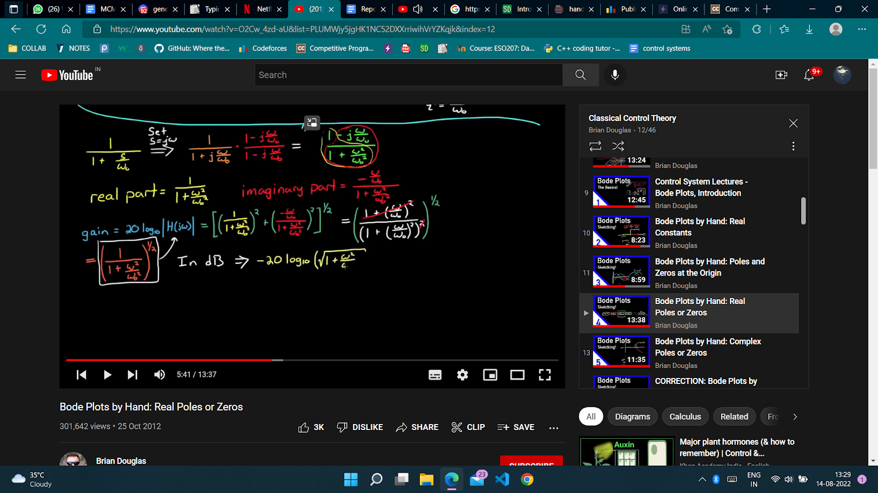

We draw the corresponding graph for gain in dB and phase angle considering cases for w relative to wo,

Gain in db gain;

degree phase;

If (w<<wo) {

gain= 0; degree=0;}

else if (w==wo) {gain= -3; degree= -45;}

else if (w>> wo){ gain= -20 dB/decade; degree= -90;}

These are just a few approximations to draw an actual graph kind of like we use envelopes to draw a graph. We draw the lines mentioned above and then the actual graph approximated by it: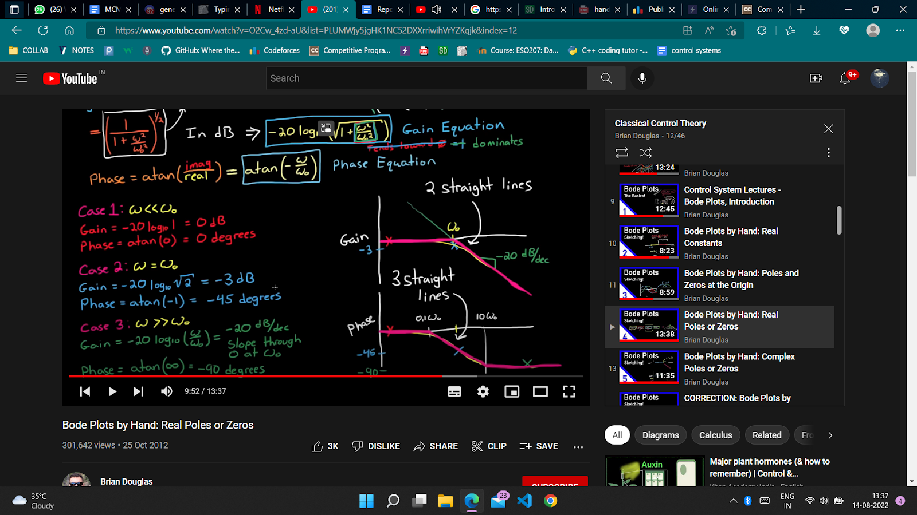

In the case for zeroes under this case i.e $1+\frac{ω}{ωo}$. This is again the PRE-2 and the result is going to be a reflection of the above case about the x-axis.

**CASE 2 (COMPLEX POLE or ZERO):**

They are always going to be in pairs (basic maths). $T=\frac{{ωo}^{2}}{s^{2}+2ζωo+ωo^{2}}$.

This can be manipulated and the corresponding complex function can be found. The real and imaginary parts of the function are :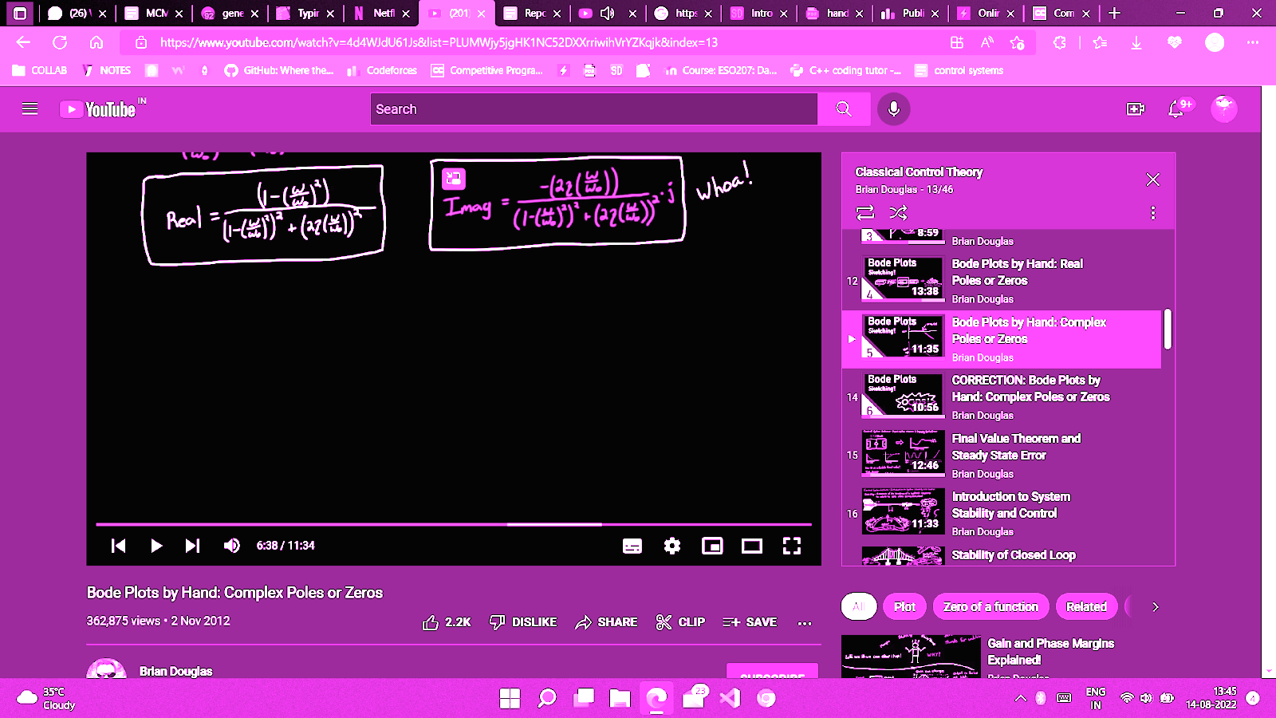

Again subcases like before:

If (w<<wo){ gain = 0 ; degree= 0; }

else if (w>>wo){ gain = - 40 dB/decade;

degree = -180; // because it approaches from 3rd quadrant }

else if (w==wo) { gain = $-20 log (2ζ)$; // interpret it for diff values of $ζ$ 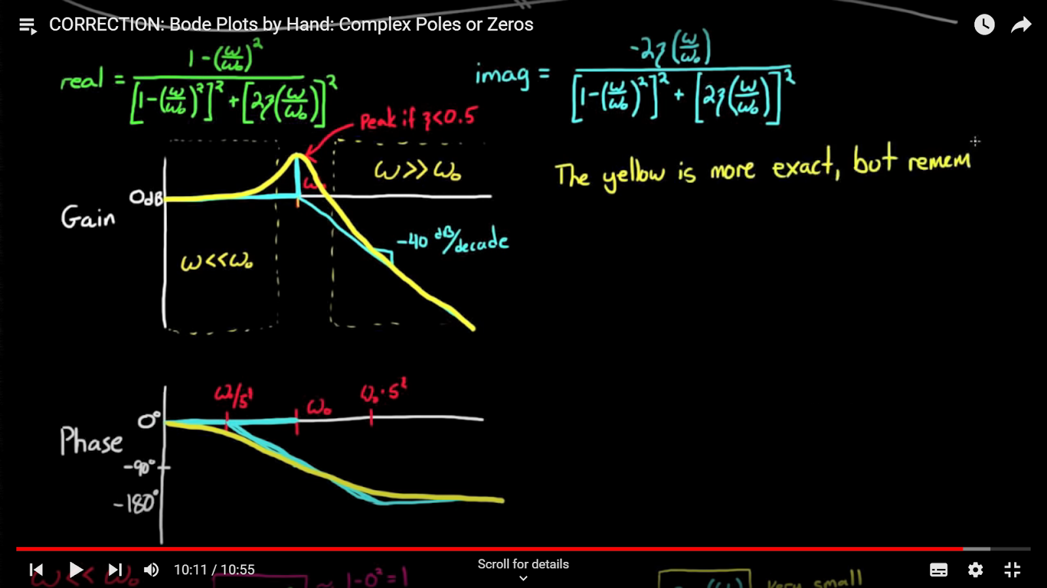

degree = -90;}

The graph we get is :

For the zeroes being complex we again reflect it about the x axis.

**FINAL VALUE THEOREM:**

It is used to calculate the value of X(t) when the t → ∞ or the value of steady state of the output. The theorem states that $\lim_{t→∞}X(t)=\lim_{s→0}sX(s) .$ However this theorem has some constraints on when we can apply this to a system.

We can take cases on $σ \& ω$ of the poles :

$σ > 0$: In this case the limit of the system is always going to go infinitely because of the exponential increasing term .

$σ =0 \& ω≠ 0$: This means that the s is going to lie on the imaginary axis excluding the origin. This implies for the function to include sinusoidal parts which do not exist at the limit.

$σ =0 \& ω= 0$: In this case we can apply the final value theorem .

$σ< 0$: Here due to exponentially decaying terms the limit is always going to go to zero and that is what we get from the Final value theorem, hence it is applicable here too.

RESULTS: it can be applied if ALL the poles lie on origin or explicitly in the 2nd or 3rd quadrant. Examples:

1. s/s+2 : here applicable hence the limit is 0.
2. s/s-2 : here not applicable and the limit is actually ∞ .
3. s/s^2 + 4 : here also not applicable as the limit is oscillatory due to sinusoidal functions.

*~ In Step type of input (1/s) with poles that satisfy above conditions we draw a conclusion : lim (s*1/s*transfer function ) is basically the c1/c2 where the c1 and c2 are constant terms in Numerator and denominator.*

*~ We calculated the error term for closed loop term in terms of desired value and the transfer function. We use the final value theorem to get the steady state error.*

**STABILITY OF SYSTEMS**

When we say that something is stable we mean that it won't be affected in the long term by some ups and downs. Same goes for a system. We say that a stable system is a system whose response to an impulse decays to zero or reaches to zero. This implies that if we give a stable system an impulse the system will show behaviour that will decrease to reach zero.

As we can always imagine a bounded or finite input as a sum of impulses as shown below :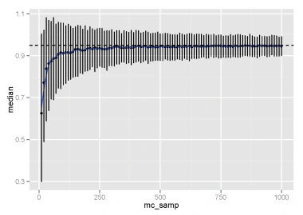

These impulses or the bounded finite input will also give an output that decays to zero however that may not be continuously decreasing. This is called BIBO *i.e*  “Big Input Big Output”

This is important for a system because if it is unstable it wont come back to its equilibrium state at all on its own. The system cant be too stable also because that would mean that the system decays quickly hence it wouldn't give us any visible response. CONCLUSION : We need a stable system which is not too stable and not slight but in between.

**HOW TO DETERMINE STABILITY?**

Poles are what determine stability. We first convert the closed loop system to open one and then we see the transfer function. If all the poles are in the left part of the argand plane (including the imaginary axis(in which case it will be marginally stable)) , then the system is stable else it's unstable.

Hence we need to find the sign of the real part of the roots of the denominator in the Transfer function.

There are a few methods for this :

1. If the polynomial has even a single sign change it has a root in the positive half because the sign change implies that there are roots of opposite sign which implies at least one in the right part of the argand plane. $eg : P(s) = as^{2}-bs-k ⇒ at least one opp sign pair (may not be equal in magnitude) of roots.$
2. *Routh-Hurwitz Criterion :*

This is a method for determining the sign of roots. We create an array according to the polynomial that we have, It is called the ROUTH ARRAY. Take for example :

$$s^{4}+2s^{3}+3s^{2}+10s+8$$

1. Number the rows not 1 , 2 , 3.. But as $s^{4}, s^{3},s^{2}...$ start from max power and cover all powers (even if not present in the equation). Write the alternate coefficients start from max power in the first row ($s^{4} row$). Here the first row will be 1 3 8.
2. The second row will be 2 10 .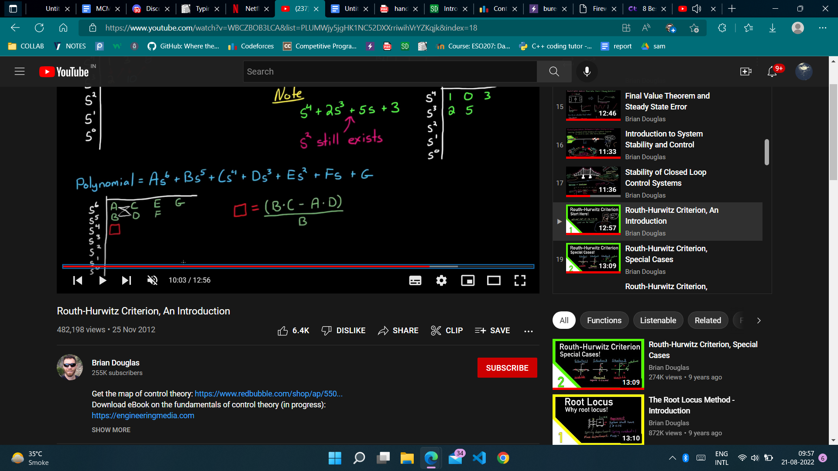
4. We fill the subsequent rows like this. If the above required element for calculation is not present then calculate it by putting zero in the second topmost row.
5. We do it till we reach the last $s^{0}$ row and then we see the number of sign changes in the first column and that is the number of roots in the RHP.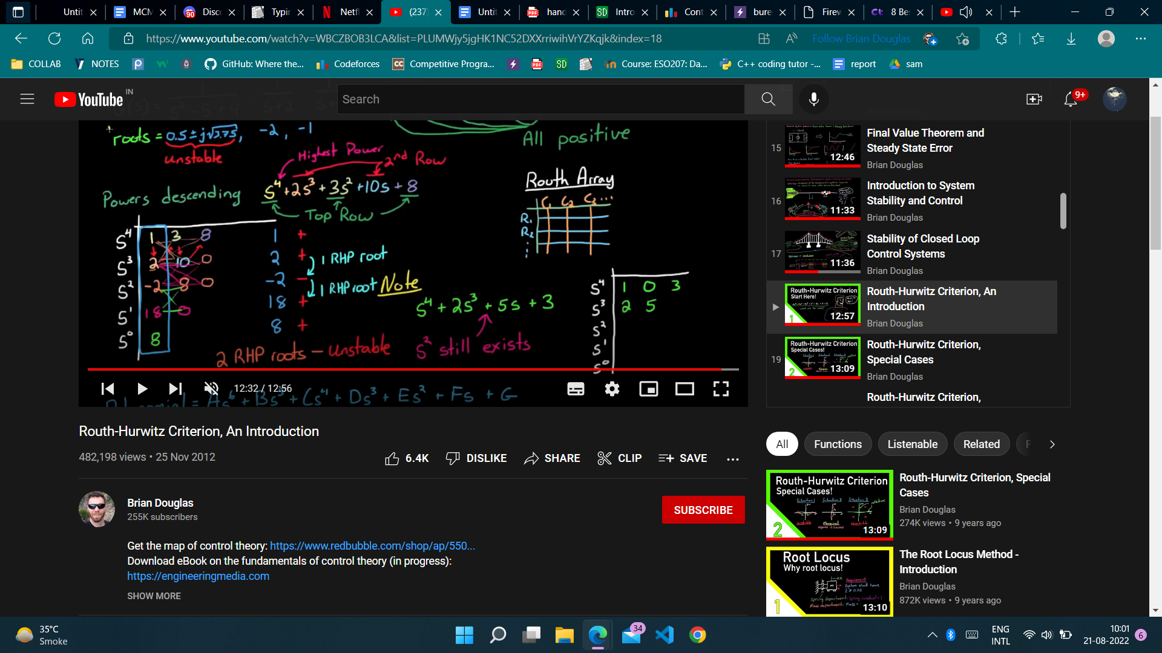
6. The matrix in above example is :

There are two sign changes above as 2 → -12 and -12→ 18. Hence two RHP roots.

**SPECIAL CASES:**

1* If there is zero in a row and a non zero element in the same row afterwards then we can directly say that the system is unstable.

2* An entire row is zero then We take the row above it and write a polynomial with its coefficients as power as the row and reduce it to its lowest form {IT WILL BE A FACTOR OF THE ORIGINAL POLYNOMIAL} and then take the derivative. The polynomial that we get is used to replace the zero row.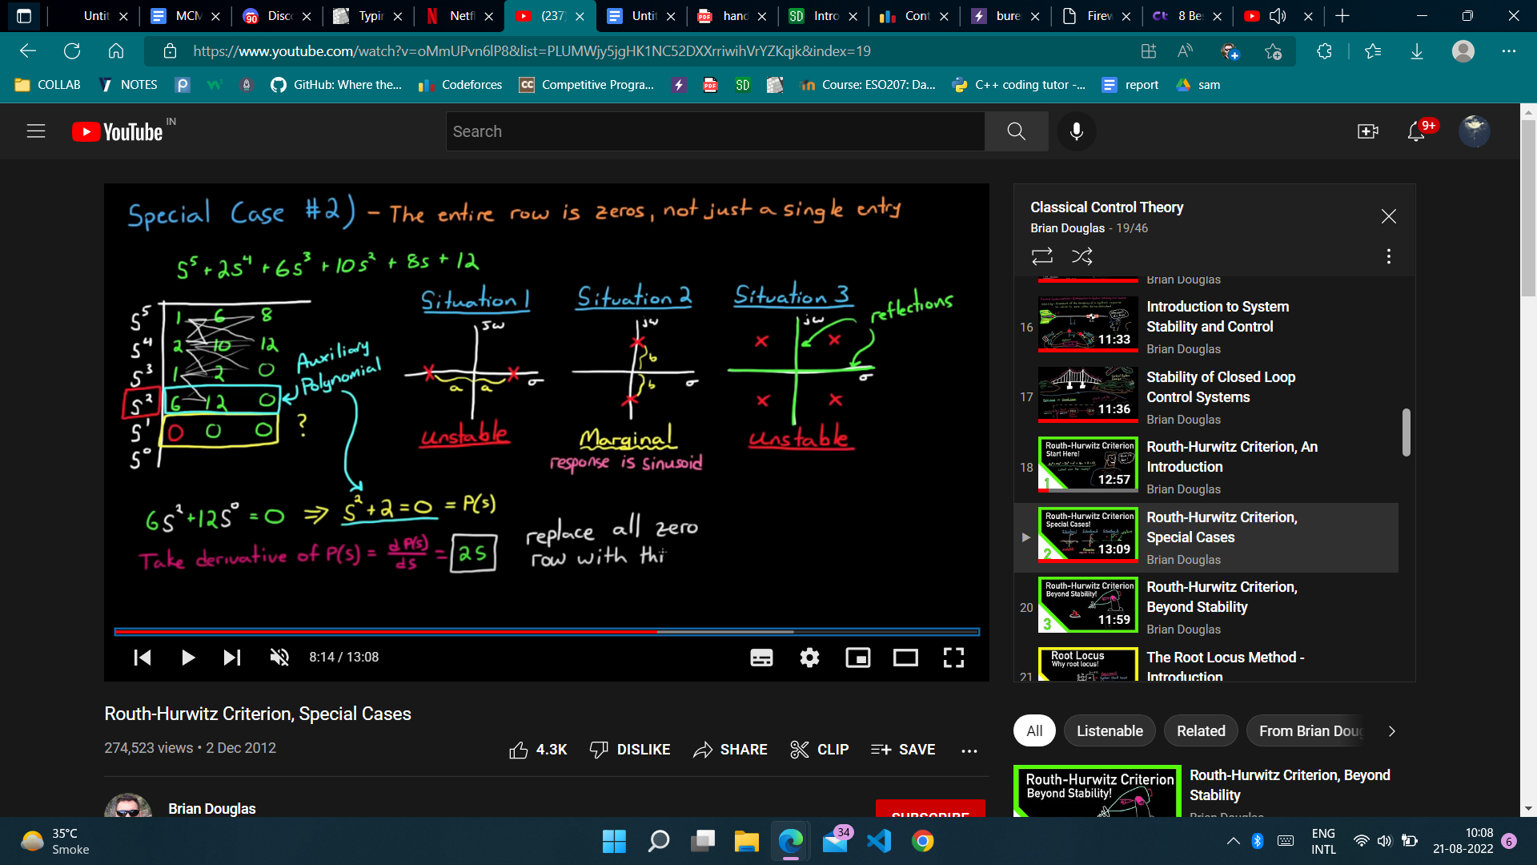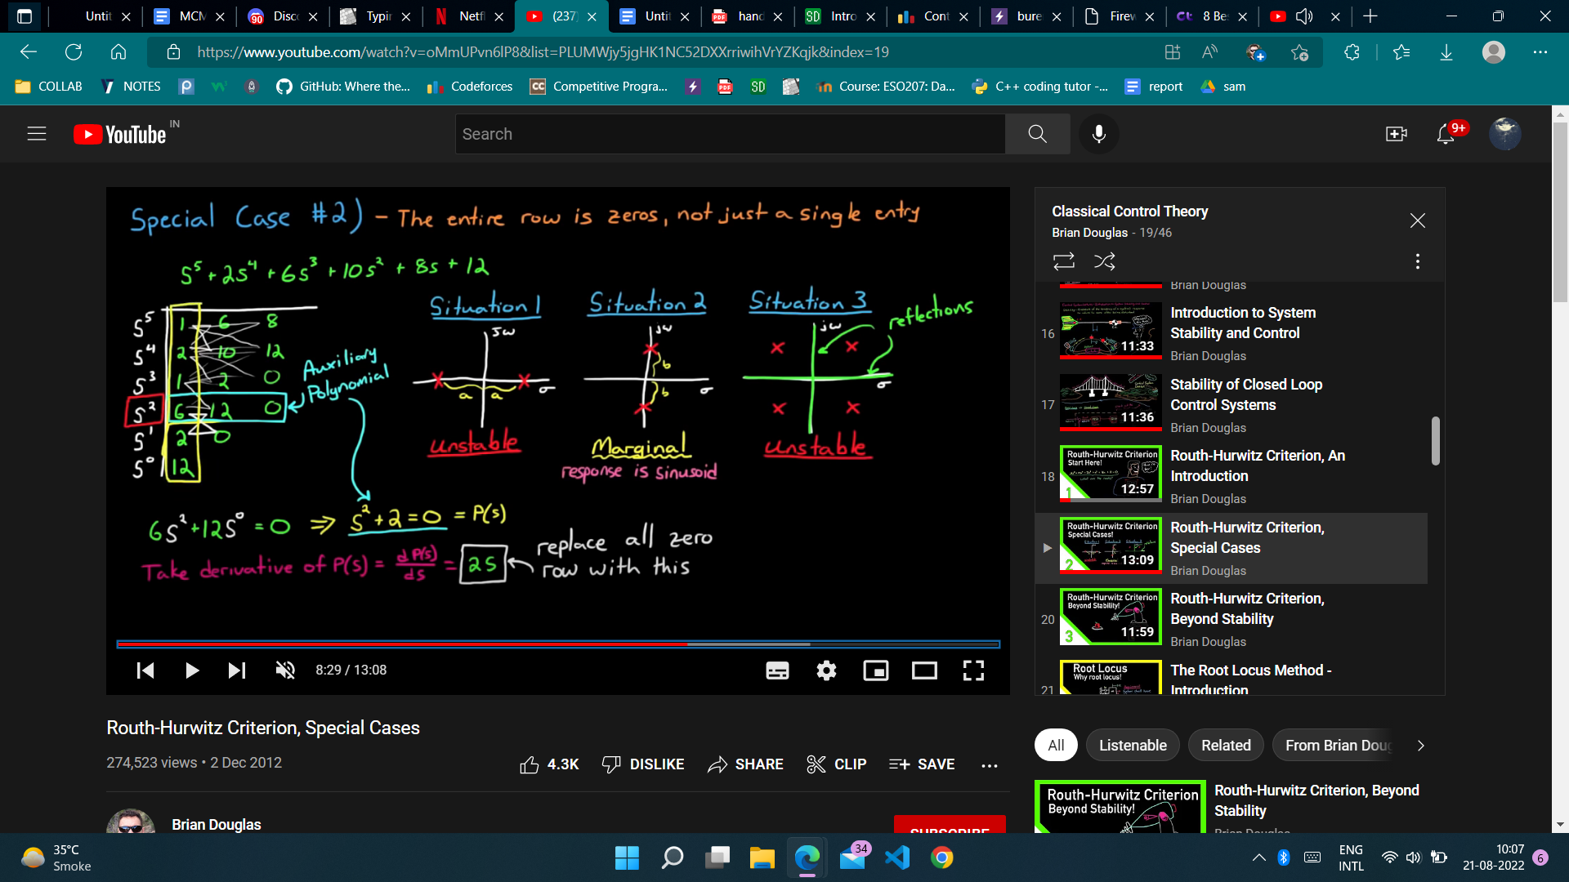

Eg :

**WHAT IS ROOT LOCUS ?**

I have a system in my hands. I see that it is unstable or has different stability than is required. I ll add more terms in the transfer function to get poles of my choice. But how? Root locus is something that resolves this issue.

Let's start with a transformation of transfer function (say G(s)) adding another term ‘k’ in the closed loop i.e U→K→G(s) → output and feedback to U

This can be summarised as an open loop system of transfer function :

$$\frac{k G(s)}{1+k G(s)}$$

Now we vary the k and see the change in poles and stop when we get the desired result. We can use MATLAB to plot them but it's better to have a picture in mind on variation of poles with the k. The plot we get is known as Root Locus.

Now we will start with the general form and state a couple of rules to keep in mind.

Write the polynomial in the denominator as say P(s) + kQ(s).

Divide by P(s) and we get 1+kQ(s)/P(s) where the Q(s)/P(s) is referred to as the G(s). This is the basic form we stated above. So we want the roots of 1 + k*G(s)=0.

**RULES :**

1. There are going to be n lines where n is the degree of Q or P whichever greater. By line we mean that when we plot the graph we will see that there will be no arrows where each arrow will tell us about the direction of movement of roots as k → ∞ .
2. As k increases the roots move (direction) from poles to zeros of G. This is because as k=0 the roots are P=0 i.e poles of G and when k→ ∞ the roots tend to be the zeroes of G. This is also the explanation of rule 1.
3. If there are more poles than zeros then the extra ones go to infinity. If there are more zeros than the extra ones will be reached by the poles at infinity (assuming)
4. Let's say we have a root and we are observing its path as k changes then it will never cross its path. Two initial diff roots may cross but one root cannot cross itself again.
5. Complex roots occur in pairs and they follow a path that is exactly the reflection of the other about the x-axis.
6. The critical frequencies (zeroes and poles present on the x-axis) are labelled as 1,2,3… starting from the rightmost one. Then the x-axis is the part of the locus of lines joining the odd ones to the next even ones. If the last number is odd then the whole of the x-axis after this critical frequency is a part of the locus.Lets say we have to connect two poles because of this (not possible) hence the lines will diverge at some point (maintain the integrity of the rule) in opposite directions.
7. The lines can leave or enter the x-axis at right angles only.
8. The lines go to infinity along asymptotes.
9. If at least two lines go to infinity the sum of all roots is constant.
10. If k → -∞ then the locus will be reversing the rule 5 and adding 180 degrees to the asymptotes.

The angle of asymptotes is :

$θ =( \frac{2q+1}{n-m})*180$ in degrees. Here the q is 0,1,2,3…n-m-1.

And then=poles , m=zeroes.

The centroid of these asymptotes is given by :

$=( \frac{\sum{}finite poles - \sum{}finite zeroes}{n-m})$.

**NYQUIST PLOT FOR STABILITY**

When we are calculating the poles in the transfer function the work using the routh array can get tedious so we use Nyquist plot . It is based on the Cauchy Argument Principle stated below:

**Cauchy Argument Principle:**

Assume a function T . Given its poles and zeros, If we draw a contour plot, say in w-plane, then the number of times it encompassesin clockwise direction the origin is equal to the number of zeroes exceeding the poles in that contour plot in the s-plane. If it is in an anticlockwise direction then the poles are that number more than the zeroes.

*COROLLARY:*

If we add a constant to the function then instead of origin we take the negative of that point as reference for encompassing in the w-plane.

For example :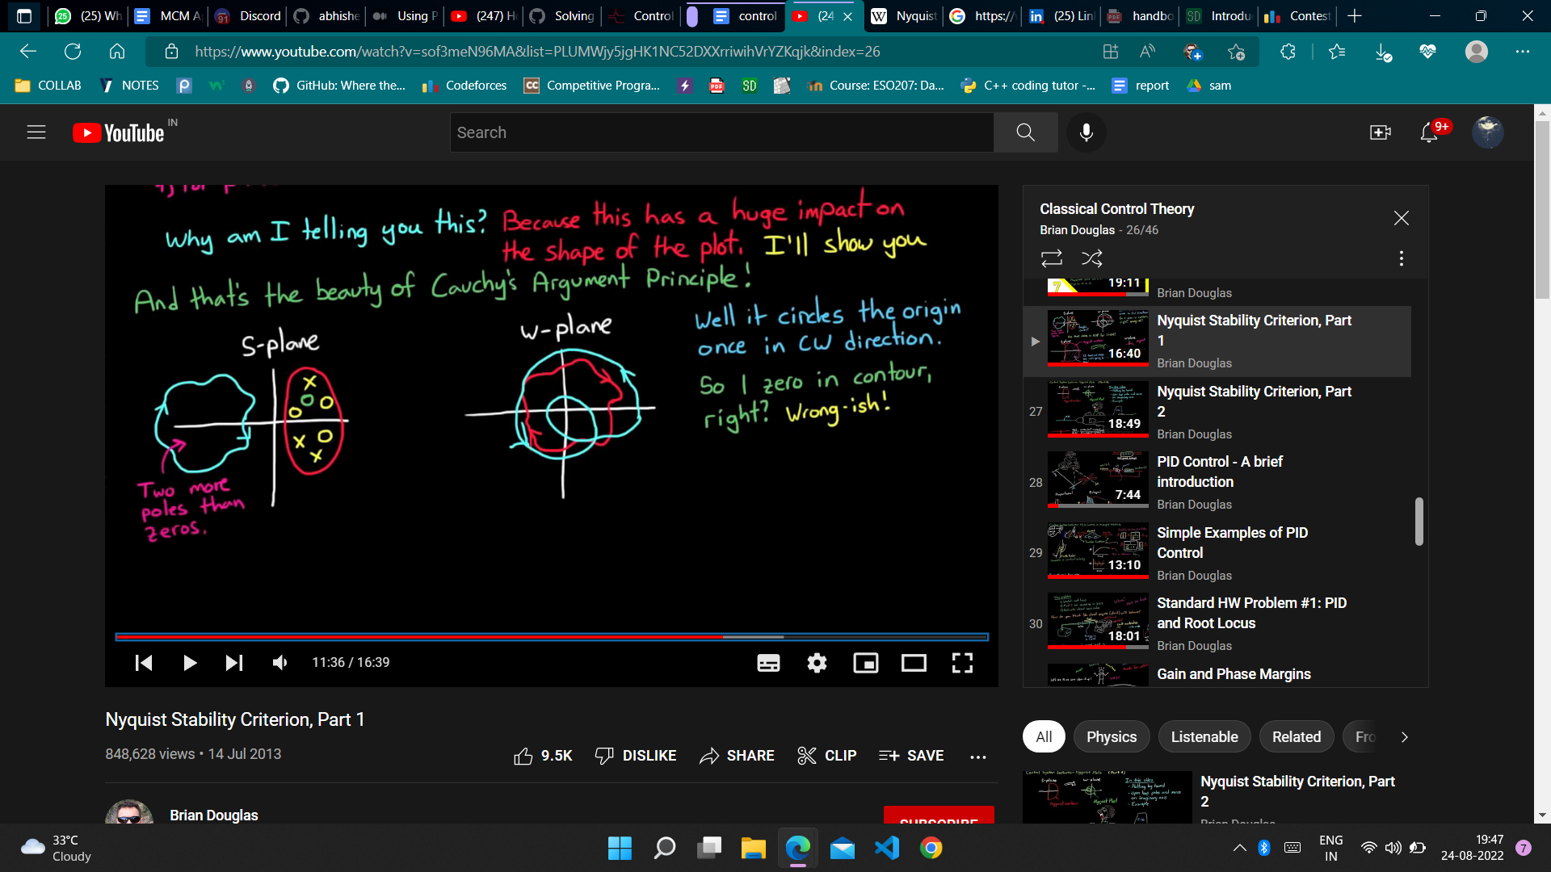

Here the contour is in the s-plane that is my reference. I pass the contour through my transfer function and get the plot in w-plane as shown. The plot (in RED) has origin once in it in C.W direction hence the transfer function in the original contour plot region has 1 more zero than poles. In the Blue one it is anti and has origin in it twice so it has two more poles than zeros in the resp. contour in the s-plane.

Coming back to nyquist. We take a contour in the s-plane as RHP *i.e* It travels along the imaginary axis from -∞ to +∞ and then encompasses the whole RHP and goes back to -∞ on the imaginary axis. We take RHP into consideration because the stability depends on it.

We will see this criteria for a closed loop system with G as transfer function and the H as the feedback function. The open loop function hence becomes : $\frac{G}{1+GH}$. I want the zeroes of the function 1+GH hence my function T= GH and take -1 as centre in the w-plane because poles of GH are the same as the poles of 1+GH (or use corollary states above). We know the equation zeroes in the *contour = poles + encompasses (C.W)*

This can be stated in a compact form as **Z=N+P.** Z is the number of zeroes , N is the number of times it encircles -1 and P is the number of poles.

Attention : → If There are poles on the imaginary axis. Then when I pass that point through my function then it will blow up. But what we can do is we can skip that point as if a speed breaker is present on it . This won't create a problem as we are concerned about the zeroes of 1+GH or the poles of the original function in complete RHP.

***A HELP:*** *How to draw the contour → put s in GH as ‘iw’ → vary the w from -∞ to +∞ .*

1. *For the part where it covers the radial part, The whole part is just one point for proper functions (degree of num <= degree of denom). As I will prove below:*

*The whole part is basically ‘s=a+ib’ then we have to put a and b as both +∞ and we get a large number / large or larger number which gives us a magnitude of finite number or zero. The phase angle is zero because if we put it we get it is equal to zero angle-pole angles which is angle made with zeroes and angle made with poles. This is zero if the a+ib is at infinity. Hence proved! We don't include this point in the calculation because a point cannot create a difference between the no of encircles.*

1. *The part for other one we put in s= iw and then we find 4 values:*

*For w=0 w= ∞ and those w for which the contour will cross the real line and those for which it will become imaginary.*

*Example : The closed loop transfer function is G= $\frac{1}{s^{2}+3s+2}$, H=1*

We put s= iw and then w=0 and w=∞. We get ½ and 0 values. Then we put its real part equal to zero and then imaginary one. We get w= $\sqrt{2}$ and w=0 or ∞.

We make a curve joining the value we get on these points and then reflect whatever we get about the x-axis to get the curve for the -∞ part of iw.

We get :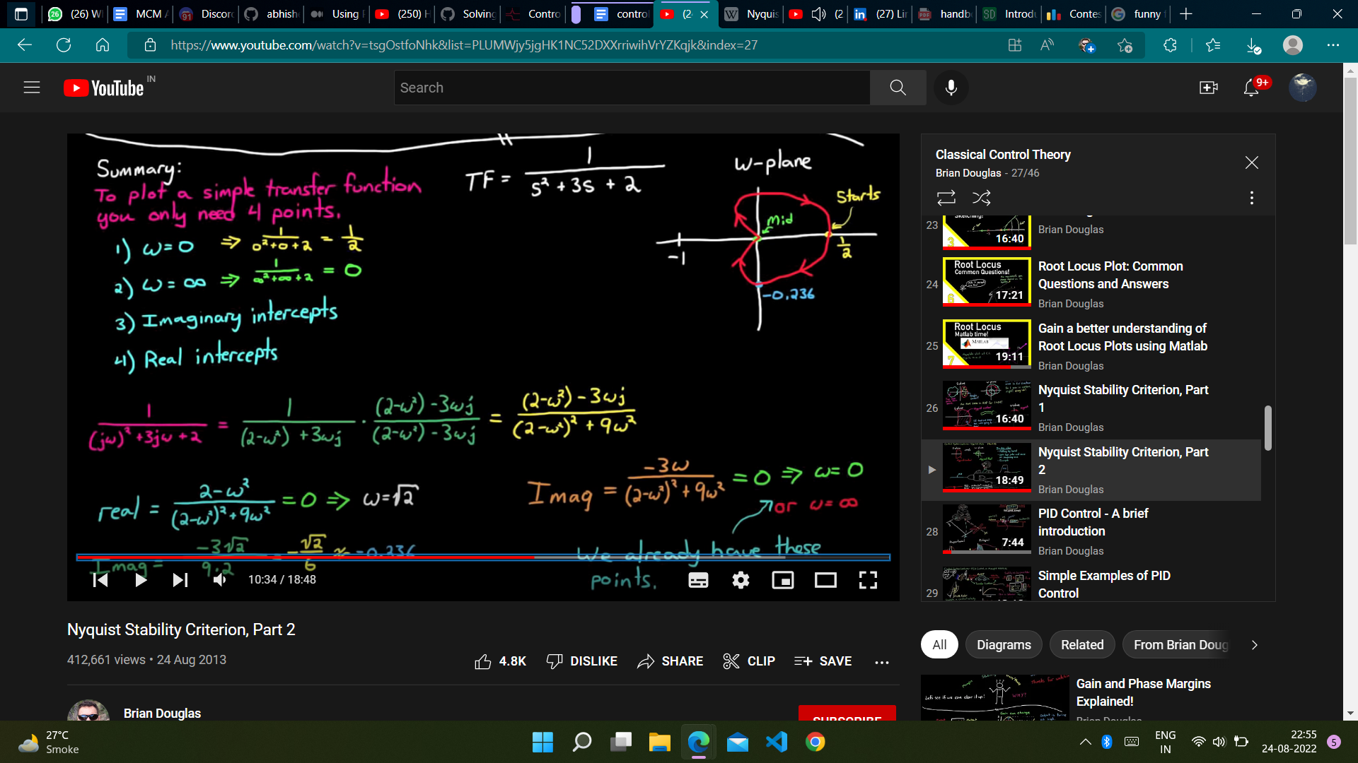

**PID**

When we are trying to control a system we need to account for the error term. We put in a couple of transfer functions in it to make the error term approach to zero ultimately. But what is this transfer function that we use?

We use a transfer function that takes into the error term and

1. P : Adds a term that is proportional to it
2. I : Adds a term that is proportional to its derivative or its change wrt time
3. D: Adds a term that is proportional to its integration or accumulation over time.

This is the P I D control system.

In the laplace domain we are able to simplify it in algebraic terms .

The P control turns out to be ${ K}_{p}$

The D control turns out to be ${ K}_{d} s$

The I control turns out to be ${ K}_{I} {1/s}_{}$

**VISUALISE :**

1. ets say I want to rotate a disc by 360 angle and I design a system. It initially rotates by 200 degrees then error is 160 and I implement the P control and I add a quantity Kp*160 and then again get some error (lesser) and it goes on and I ll ultimately reach The zero error state. This is how the P controller helps.
2. I want to stop a car at some position. I use P control to control the gas in the car. Initially there is some distance (error) and it increases the gas (positive error) and like this when it reaches the point error is zero but gas is still running and the car will go forward. Error will be negative and P control will give a negative addition and then the car will go back and this oscillation will continue. Here is where D helps. I add the D control and it sees that the distance (error) is decreasing and hence It is negative and adds a negative term when the P controls adds a positive term . The D control will ultimately put it to zero gas by continuously reducing the gas.
3. I want to surpass a car and then stay along with it. I use P and D control and then we see that It increases gas acc to P and D reduces the gas because the distance between the cars is decreasing and when it reaches the car the gas will stop because of D and the car which we were chasing will go away. Here we use I control. I control the error at all times. Basically it integrates over time and when the I would have reached the car the I term will not be zero it will be positive and it will not let us go off the gas and help us maintain the velocity because it will be constant (error now zero hence no further accumulation).

**PID and Root Locus**

We will solve a problem of PID and root locus and understand it as an exercise in this section.

Given is transfer function of a shaft speed vs valve setting in a machine as : 1/ 0.01s^2 + 0.11s + 0.1

The PID function as : 5 + 0.3s + 5/s $τ$, $τ$ is a variable that we have to control ourselves.

1. Sketch root locus
2. Find $τ$ for damping to be >=0.7
3. Estimate closed loop poles

Root locus :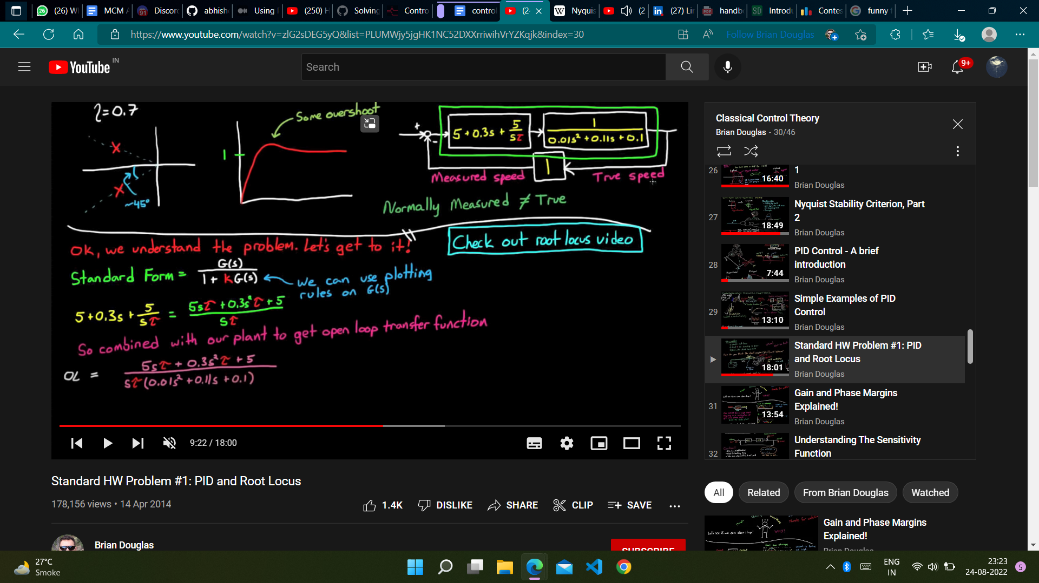

The denominator or our function for root locus in open loop is : 1+

We put it in the standard form and find P and Q as :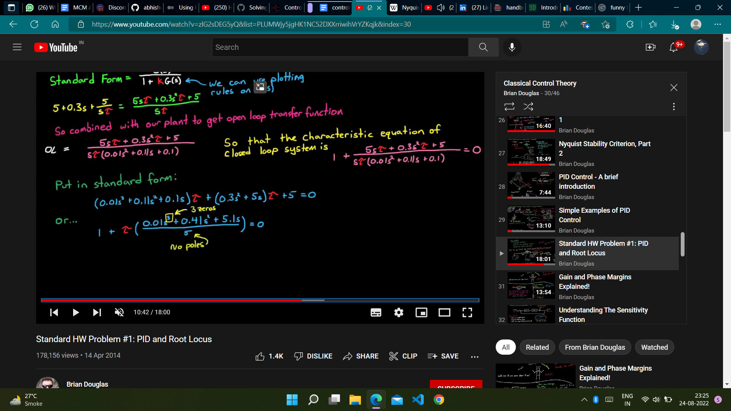

The centre from our above formula is : -13.7

The angles that we get are +-60 and 180 degrees. This gives us following root locus :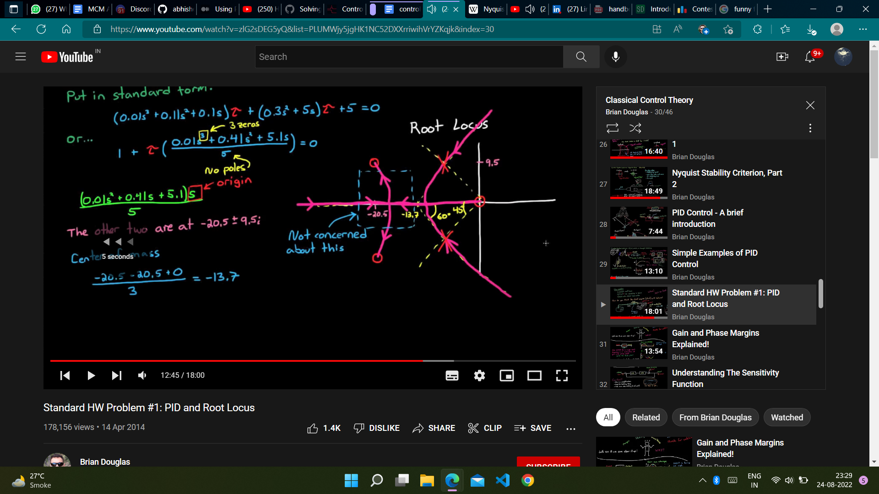

For the damping we don't need the blue region.

The damping :

The poles will be very near to asymptotes. So we can assume that the damping line will intersect the asymptotes at the required poles and using basic calculations of maths we can get the poles as :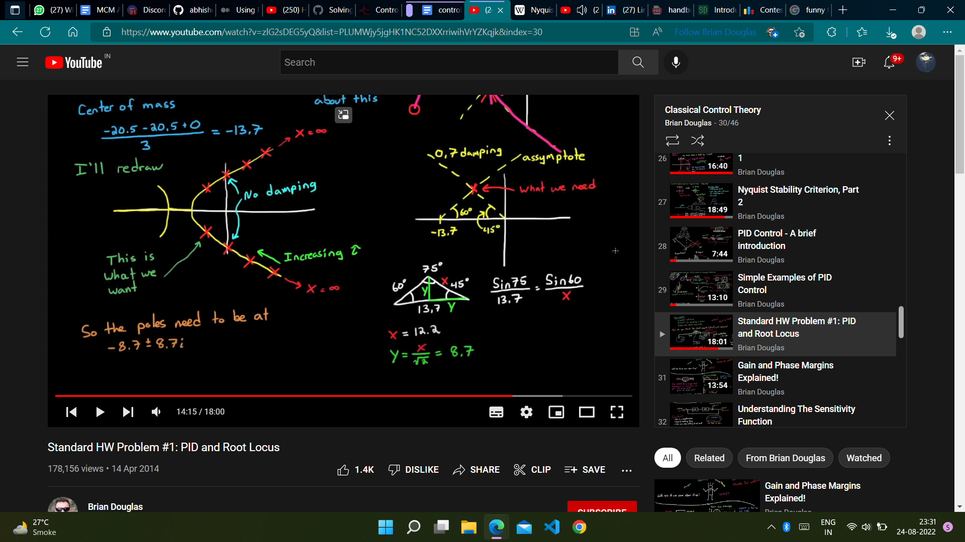

The third root can be found using the fact that their sum is constant. It is -23.6. Now that we know our roots we can find the $τ$. It is 0.16 or greater.